1 – 5 – Recognizing Transformations – Teaching Set
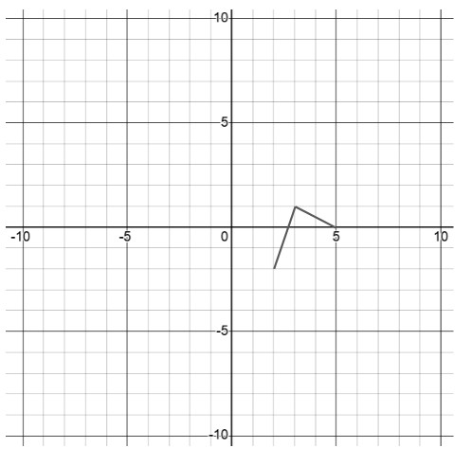
1. [C]
A: (2,-2)
This small graph is the function $y=f(x)$
For each, say out loud what the transformation will do.
Write the coordinates for where point A will end up after the transformation.
a. $y=f\left(x\right)+7$ b. $y=f(x+3)$
c. $y=f(-x)$ d. $y=f\left(\frac{x}{2}\right)$
e. $y=-3⋅f(-x)$

2. [C] Ideally these should take < 1.5 min each.
For each problem, i). decide what basic family it is and how has it been transformed, and
ii). make a squick sketch of the shape and important features without making a table of values (or using technology).
a). Consider $f\left(x\right)=\frac{1}{x+2}+1$.
b). Consider $g\left(x\right)=-{\left(x-1\right)}^{3}+1$.
c). Consider $g\left(x\right)=5^{-x}$.

3. [C]. We’re going to start with $y=x$ and apply several transformations. At each step, say what transformation we did from the previous step, and then sketch the result.
a. Try and imagine these steps like a little animation
$$y=x$$ | $$y=3x$$ | $$y=3(x-5)$$ | $$y=3\left(x-5\right)+1$$
Sketch. Label $(0, 0)$ as point p. | Sketch. lable p. | Sketch, label P | Sketch, label P.

b. Notice we ended with a line that’s slope is 3, which goes through the point (5, 1).Use this same idea to write an equation for 3 more lines that go through the point (5, 1).
c. Use this same idea to rapidly write the equation for a parallel line that goes through the point (10, 7).
d. When you write a linear equation in the form $y=k\left(x-a\right)+b$ its called point-slope form. What does k represent? What do a and b represent? You’ll use this form a lot in calculus, so it will be a good idea to get comfortable thinking of it as an option when you need a line!

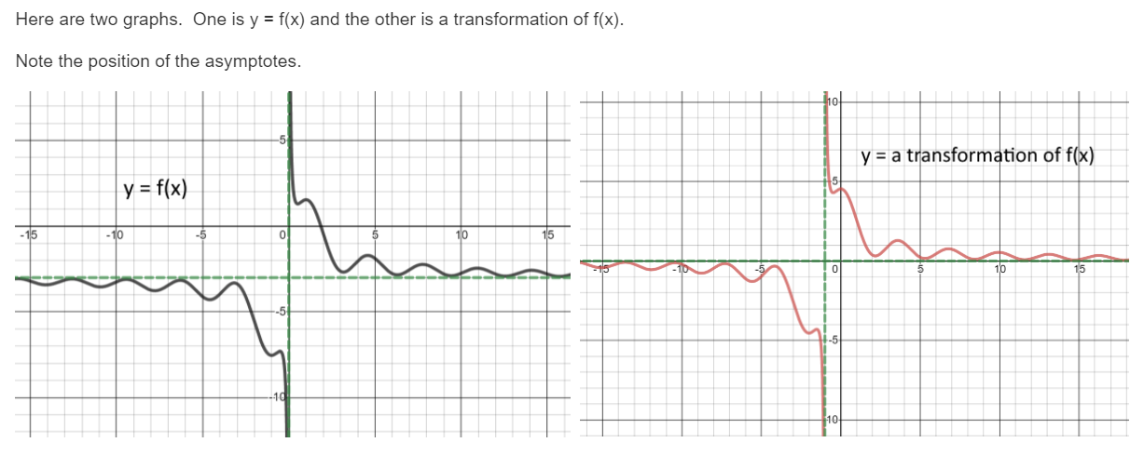
4. [C] Here’s a graph of $y=f(x)$ and a transformation of $f(x)$. Write the equation that describes the transformed graph in terms of f(x)
5. [P]
Let $f\left(x\right)=x^{3}-x^{2}$
Write a new equation for $f(x)$ if you….
i). horizontally reflect it? ii). Vertically reflect it?
iii). Shift it left by 2? iv). Shift it down by 1?

6. [P/C]
Let $f\left(x\right)=4-\sqrt{x}$
Write a new equation for $f(x)$ if you…
i). shift it left by 3 units?
ii). What equation do I get if I vertically reflect just the $\sqrt{x}$ term?
iii). What equation do I get if I vertically reflect the entire $f(x)$?
iv). Discuss: what’s the original f(x) graph look like? What do the graphs of ii and iii look like? Notice that ii and iii both vertically reflect, but they’re reflecting differently. Be sure it makes sense how and why they’re different.

7. [C] If (10, 6) is a point on $y=f(x)$, what’s a point on the curve $y=-\frac{f\left(-x\right)}{2}+1$ ?

1 – 5 – Transformations – Solutions
1. [C] This small graph is the function $y=f(x)$
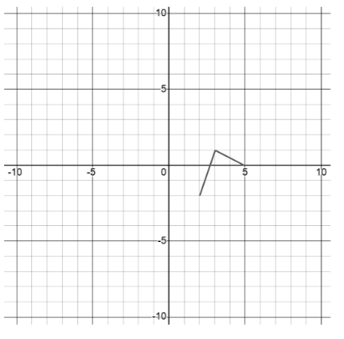
Sketch each of the following on the same axes.
(If you’re doing it on the whiteboard, label the 3 reference points)
a. $y=f\left(x\right)+7$ shift up by 7 (2, -2) (2, 5)
b. $y=f(x+3)$ shift left by 3 (2, -2) (2, -5)
c. $y=f(-x)$ horizontal reflection (across y-axis)
(2, -2) (-2, -2)
d. $y=f\left(\frac{x}{2}\right)$ horizontal stretch by factor of 2
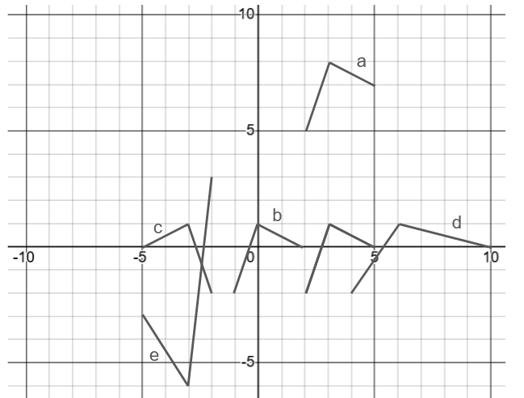
(2, -2) (4, -2)
e. $y=-3f(-x)$ vertical stretch by factor of 3 and vertical reflection and horizontal reflection.
(2, -2) (-2, 6)

Here’s what they’d all look like:

2. [C]
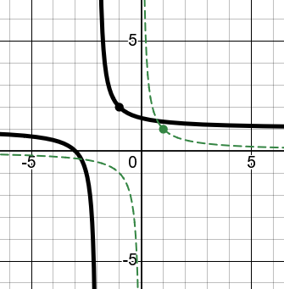
a). $f\left(x\right)=\frac{1}{x+2}+1$ is the family $y=\frac{1}{x}$ and it’s been shifted left 2 and up 1.
Imagine taking the reference point at (1, 1) and shifting it to (-1, 2).

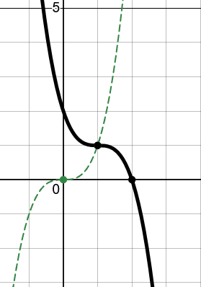
b). $g\left(x\right)=-{\left(x-1\right)}^{3}+1$ is the family $y=x^{3}$ and has been shifted right 1, vertically reflected and shifted up 1.

c). $g\left(x\right)=5^{-x}$ is the $y=5^{x}$ family and has been horizontally reflected
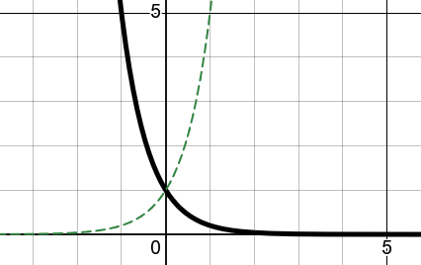

3. [C]. We’re going to start with $y=x$ and apply several transformations. At each step, say what transformation we did from the previous step, and then sketch the result.
a. Try and imagine these steps like a little animation. We stretch the line to have a slope we want, then shift $(0, 0)$ to $(5, 1)$.
$$y=x$$ | $$y=3x$$ | $$y=3(x-5)$$ | $$y=3\left(x-5\right)+1$$
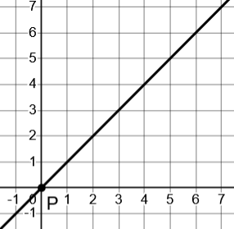 | Vertically stretch by 3  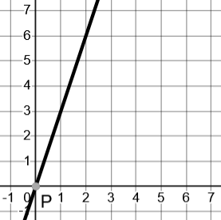 | Shift right by 5  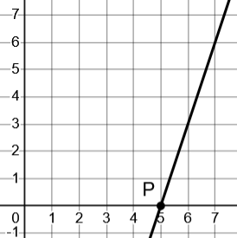 | Shift up by 1  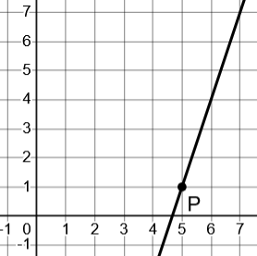

b. Notice we ended with a line that’s slope is 3, which goes through the point (5, 1).Use this same idea to write an equation for 3 more lines that go through the point (5, 1).
What if we started with other slopes besides $y=3x$ before we shift right by 5 and up by 1? For example:
$y=-12x$ shift it to go through (5, 1) $y=-12\left(x-5\right)+1$
$y=7x$ shift it to go through (5, 1) $y=7\left(x-5\right)+1$
$y=\frac{1}{2}x$ shift it to go through (5, 1) $y=\frac{1}{2}\left(x-5\right)+1$
c. Use this same idea to rapidly write the equation for a parallel line that goes through the point (10, 7).
If its parallel, we know the slope must be 3. But instead of shifting $y=3x$ right by 3 and up by 1, let’s shift it right by 10 and up by 7 to get: $y=3\left(x-10\right)+7$
d. When you write a linear equation in the form $y=k\left(x-a\right)+b$ its called point-slope form. What does k represent? What do a and b represent?
k represents the slope. a is how far we shifted right and b is how far we shifted up. So $(a, b)$ represents the coordinates of the point that $(0, 0)$ shifted to. Therefore we also know that $(a, b)$ is a point on the line.


4. [C] Here’s a graph of $y=f(x)$ and a transformation of $f(x)$. Write the equation that describes the transformed graph in terms of f(x)
In the original equation, the asymptotes cross at (0, -3). After the transformation they cross at (-1, 0). The rest of the curve looks the same – it doesn’t look like it’s been stretched or squished or reflected. So it must just have shifted left and up. Therefore the equation is $y=f\left(x+1\right)+3$

5. [P]
Let $f\left(x\right)=x^{3}-x^{2}$ What’s the equation if you…
i). horizontally reflect it? $f\left(x\right)={\left(-x\right)}^{3}-{\left(-x\right)}^{2}=-x^{3}-x^{2}$
ii). Vertically reflect it? $f\left(x\right)=-\left(x^{3}-x^{2}\right)=-x^{3}+x^{2}$
iii). Shift it left by 2? $f\left(x\right)={\left(x+2\right)}^{3}-{\left(x+2\right)}^{2}$
iv). Shift it down by 1? $f\left(x\right)=x^{3}-x^{2}-1$

6. [P/C] $f\left(x\right)=4-\sqrt{x}$ What’s the equation if you…
i). shift it left by 3 units? $f\left(x\right)=4-\sqrt{x+3}$
ii). What equation do I get if I vertically reflect just the $\sqrt{x}$ term? $f\left(x\right)=4+\sqrt{x}$
iii). What equation do I get if I vertically reflect the entire $f(x)$? $f\left(x\right)=-4+\sqrt{x}$
iv). Discuss: what’s the original f(x) graph look like? What do the graphs of ii and iii look like? Notice that ii and iii both vertically reflect, but they’re reflecting differently. Be sure it makes sense how and why they’re different.
The original graph is an upside down root shifted up by 4. Graph ii just flips the root over where it is at y = 4. Graph iii reflects the entire graph around the x-axis, so it ends up down at y = -4, right side up.

7. [P/C] If (10, 6) is a point on $y=f(x)$, what’s a point on the curve $y=-\frac{f\left(-x\right)}{2}+1$ ?
If (10,6) was on the original curve, that point must have been horizontally reflected, vertically reflected and vertically squished, then shifted up by 1.
After horizontal reflection: (-10, 6) After squishing: (-10, 3)
After vertical reflection (-10, -3) Finally shifting up by 1 gives: (-10, -2).
What wouldn’t make sense is to plug in $x=10$. That immediately gives $y=-\frac{f\left(-10\right)}{2}+1$, but the problem is we don’t actually know what f(-10) is. So we’re stuck.
However, you can check that the new point works. Plug in $x=-10$ and simplify: $y=-\frac{f\left(-\left(-10\right)\right)}{2}+1$ $y=-\frac{f\left(10\right)}{2}+1$ $y=-\frac{6}{2}+1$ $y=-3+1$ -2, which is what we said the y-value should be.

1 – 6 – Finding Transformations – Teaching Set
1. [P/C]
a. Dilate $y=x^{2}$ so it goes through the point (5, 10). Make a rough sketch of it.
b. Imagine: what’s another parabola that goes through (5,10) and also the origin? Find its equation.
c. What do you notice sticking out as the same about the equations for your two solutions. Why do you think that happened?

2. [P] Find transformations of $y=\frac{1}{x}$ that go through (-5, 10)…
  - …Do it by translating horizontally, vertically, or both.
  - …Do it by vertical scaling only
  - …Do it by horizontal scaling only

3. [P] Find transformations of $y=2^{x}$ that goes through the point (-3, 10)…
- …Do it by translating horizontally, vertically, or both.
- …Do it by vertical scaling only
- …Do it by horizontal scaling only.
- Why does it make sense that your dilation faction in part c has to be negative?

4. [P/C]
a. Scale and shift $y=x$ so it has a slope of -4 and goes through the point $(19, 107)$.
(do not use $y=mx+b$ form, just think about shifting (0, 0) to the point you want).

b. Vertically scale the function $y=\sqrt[3]{x}$ so it goes through the point (-8, 10) (simplify the expression if you can).
c. Translate (horizontally, vertically or both) the equation $y=\frac{1}{x}$ so it goes through the point $(0,-21)$
d. Shift (translate) the function $y=2^{x}$ horizontally, vertically or both so it goes through (-16, -8).
e. Reflect/scale the function $y=\sqrt[4]{x}$ so it goes through the point $(7,-1)$. (you choose horizontal or vertical or both)

*5. [P/C] Make a square root function to fit this picture. (Note that this root function goes through the origin).
(20, 22)

SOLUTIONS
1.
a. Dilate $y=x^{2}$ so it goes through the point (5, 10). Make a rough sketch of it.
You could either vertically dilate it, or horizontally dilate it. You’ll get equivalent answers either way.
Vertical | $$y=k⋅x^{2}$$ | $10=k⋅5^{2}$ $k=\frac{10}{25}=\frac{2}{5}$. So: $y=\frac{2}{5}⋅x^{2}$
Horizontal | $$y={\left(kx\right)}^{2}$$ | $10={\left(k⋅5\right)}^{2}$ $10=25k^{2}$ $\frac{10}{25}=k^{2}$ $k=±\sqrt{\frac{2}{5}}$  So: $y={\left(±\sqrt{\frac{2}{5}}\right)}^{2}$
Notice that these are equivalent. You can simplify the horizontal answer into the vertical answer.
b. Imagine: what’s another parabola that goes through (5,10) and also the origin? Find its equation.

As pictured here, if we make (5, 10) the vertex, we can dilate it to go through the origin. So, first we can translate $y=x^{2}$ so it goes through $\left(5,10\right)$. Then we’ll dilate it.

I’ll shift $y=x^{2}$ right by 5 and up by 10: $y={\left(x-5\right)}^{2}+10$.

Now let’s solve for a vertical scale-factor: $y=k⋅{\left(x-5\right)}^{2}+10$
Plugging in $\left(0, 0\right)$ for x and y and solving for k: $0=k{\left(-5\right)}^{2}+10$ $k=-\frac{10}{25}=-\frac{2}{5}$.
That gives a final equation: $y=-\frac{2}{5}{\left(x-5\right)}^{2}+10$
c. Notice that we see that $\frac{2}{5}$ again. Why do you think that ended up the same as in part a?
The way I think about it is this: No matter what parabola you find, if it goes through the points (0, 0) and $(5, 10)$ it will need to be vertically stretched by the same amount.
In part a, I imagine the parabola starting at $(0, 0)$ and we vertically scaled it so it would be short enough to go through $(5, 10)$.
In part b, I imagined the parabola starting at $\left(5,10\right)$. The $-\frac{2}{5}$ flips it upside down but also scaleds it by the same amount so it will go through $(0, 0)$.

2. Find transformations of $y=\frac{1}{x}$ that go through (-5, 10)…
a. …Do it by translating horizontally, vertically, or both.
Let’s shift the reference point at (-1, -1) left by 4 and up by 11. So: $y=\frac{1}{x+4}+11$. There are other solutions that work as well, of course.

b. …Do it by vertical scaling only
I’ll add a vertical scale factor: $y=k⋅\frac{1}{x}$ , plug in (-5, 10) and solve getting $k=-50$
So $y=-50⋅\frac{1}{x}$

c. …Do it by horizontal scaling only
I’ll add a horizontal scale factor: $y=\frac{1}{kx}$, plug in (-5, 10) and solve, getting $k=\frac{1}{-50}$.
So $y=\frac{1}{\left(-\frac{1}{50}\right)x}$ , which is equivalent to part b. Because of the symmetry of $y=\frac{1}{x}$ every horizontal dilation corresponds to a vertical dilation of the same amount. Think about this claim for a little while if you’d like.

3. [P] Find transformations of $y=2^{x}$ that goes through the point (-3, 10)…
a. …Do it by translating horizontally, vertically, or both.
I’ll shift the reference point at (0, 1) left by 3 and up by 9: $y=2^{x+3}+9$

b. …Do it by vertical scaling only
$y=k⋅2^{x}$ . Plug in (-3, 10) and solve for k. This gives: $k=80$. So $y=80⋅2^{x}$

c. …Do it by horizontal scaling only.
$y=2^{kx}$ . Plug in (-3, 10) and solve for k. This gives: $k=-\frac{log_{2}\left(10\right)}{3}$.
So $y=2^{\left(-\frac{log_{2}\left(10\right)}{3}\right)x}$ The fact that it’s so awkward (and feels like it simplifies to something nicer) is a sign that this transformation is more naturally expressed as a vertical one.

d. Why does it make sense that your dilation faction in part c has to be negative?
We know it needs to be negative because the graph of $y=2^{x}$ needs to reflect horizontally to go through (-3, 10) at all.

4. [P/C]
a. Scale and shift $y=x$ so it has a slope of -4 and goes through the point $(19, 107)$.
(do not use $y=mx+b$ form, just think about shifting (0, 0) to the point you want).

First we can scale it by $-4$ to get the slope right: $y=-4x$. Then we can shift right by 19 and up by 107 to get $y=-4\left(x-19\right)+107$

b. Vertically scale the function $y=\sqrt[3]{x}$ so it goes through the point (-8, 10) (simplify the expression if you can).
Let’s add an unknown vertical scaling factor: $y=k⋅\sqrt[3]{x}$, now plug in $(-8, 10)$ to find the value for k which makes this true. $10=k⋅\sqrt[3]{-8}$ $10=k⋅\left(-2\right)$ $k=-5$
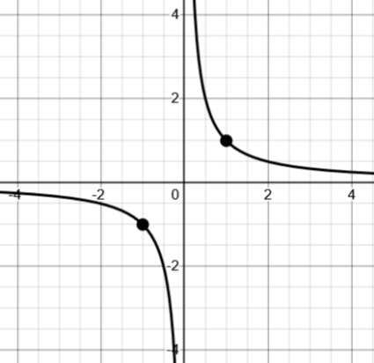
c. Translate (horizontally, vertically or both) the equation $y=\frac{1}{x}$ so it goes through the point $(0,-21)$.
Imagine the parent graph $y=\frac{1}{x}$ . Clearly we can’t only translate vertically, since there’s a vertical asymptote at $x=0$.
We could shift it so the point at $(1, 1)$ ends up at $(0,-21)$ by shifting left by 1 and down by 22: $y=\frac{1}{x+1}-22$.
Looking at the graph, we could shift it right by a very small amount to get what we need as well. Let’s figure out the x-value when $y=-21$. That’s how much we have to shift right by.
$-21=\frac{1}{x}$ $x=-\frac{1}{21}$
So, shifting right by $\frac{1}{21}$ gives us $y=\frac{1}{x - \frac{1}{21}}$.
Yet another solution would be to shift the point at $(-1, -1)$ to $(0, -21)$ by shifting right by 1 and down by 20, giving $y=\frac{1}{x+1}-20$

d. Shift (translate) the function $y=2^{x}$ horizontally, vertically or both so it goes through (-16, -8).
For me, the easiest way to imagine this is to shift the reference point at $(0,1)$ left by 16 and down by 9, giving $y=2^{x+16}-9$

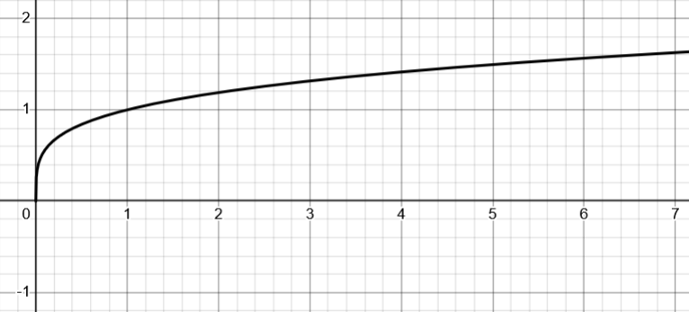
e. Reflect/scale the function $y=\sqrt[4]{x}$ so it goes through the point $(7,-1)$.
Imagining the parent graph, it feels easiest to me to reflect and scale vertically.
So $y=k⋅\sqrt[4]{x}$
Plugging in $(7, -1)$ we get:
$-1=k⋅\sqrt[4]{7}$ for some k.
$k=-\frac{1}{\sqrt[4]{7}}$ therefore: $y=-\frac{1}{\sqrt[4]{7}}⋅\sqrt[4]{x}$
We could re-structure this as follows: $y=-\frac{\sqrt[4]{x}}{\sqrt[4]{7}}$ $y=-\sqrt[4]{\frac{x}{7}}$
This suggests a maybe nicer interpretation. We horizontally stretched the point at $(1,1)$ by 7 (putting it at $(7,1)$), and then vertically reflected (putting it at $(7,-1)$ ).

*8. [P/C] Make a square root function to fit this picture.
Looking at this picture, I try and imagine a sequence of transformations that leads me from $y=\sqrt{x}$ to this picture.
(20, 22)
Here’s how I sketched it out in my mind

$$y=\sqrt{x}$$ | Vertically reflect it | Horizontally reflect it | Shift it right 20, up 22
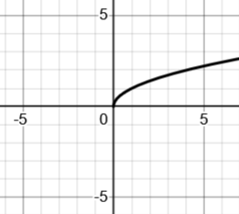 | 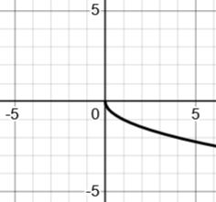 | 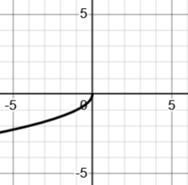 | 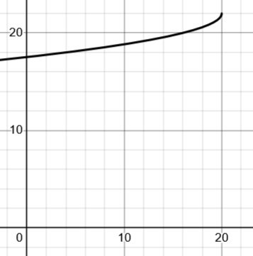
$$y=\sqrt{x}$$ | $$y=-\sqrt{x}$$ | $$y=-\sqrt{-x}$$ | $$y=-\sqrt{-\left(x-20\right)}+22$$
Ok! But something’s gone wrong. I forgot it has to go through the origin also.
I’m going to go back and think of it in a slightly different way. Let’s imagine scaling it to the size we need before the last step.

I want to scale this to the right height so that way when I shift it, it will still go through the origin.
That means at $x=-20$ I need the y-value to be $-22$. Think about why. If I have a point at $(-20, -22)$, when I shift it right 20 and up 22, it ends at the origin. The point at the origin will end at $(20, 22)$ and everything will be where it should be.

So, setting up my scale factor: $y=-k⋅\sqrt{-x}$ and plugging in the point I want:
$-22=-k\sqrt{-\left(-20\right)}$ $22=k\sqrt{20}$ $k=\frac{22}{\sqrt{20}}$
So my equation is: $y=-\frac{22}{\sqrt{20} }\sqrt{-x}$. Now I can shift it right and up to get: $y=-\frac{22}{\sqrt{20} }\sqrt{-\left(x-20\right)}+22$

